Office 365 How-To Sheet (for students)
Step 1: Login to the computer as “Guest” (not student/student.) This guarantees that nothing can be saved to the computer.

Step 2: Click “ok” on the pop-up that comes up to tell you that all files will be deleted.

Step 3: Click on “myPascoConnect”
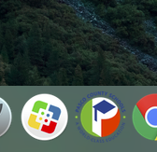
Step 4: Sign in to “myPascoConnect”
- If prompted- put in password on pop-up screen
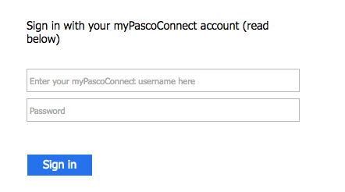
Step 5: Click on the “Office 365” app
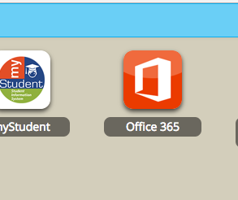
Step 6: Click on “One Drive”
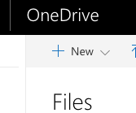

Step 7: Click on “New” to open the drop down to create a new Word document
